Supermarine S.5 Schneider Trophy 1927 companion app for MSFS

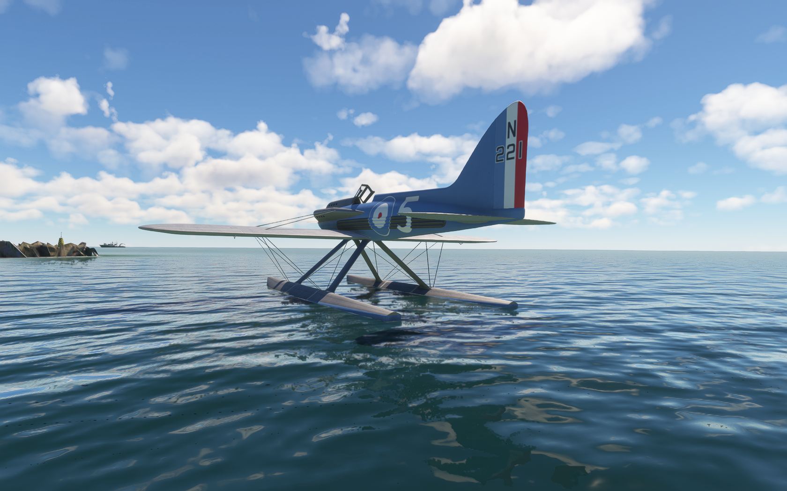

Introduction

This add‑on was inspired by a free package created by sal1800, which includes the Supermarine S.5 racing plane and a 1927 recreation of the Venice Schneider Trophy race track. After exploring this add‑on, I wanted a more automated and precise way to handle lap and race timing.

To achieve this, I used the MSFS SDK and SimConnect samples to create a small companion application that assists with racing. It works in both single‑player and, in theory, multiplayer mode. Multiple players can fly together while running their own instance of the application and compare results after the race.

History

The 1927 Schneider Trophy took place in Venice on a 50 km triangular course that had to be lapped seven times. The course stretched along the Lido in front of the Excelsior Hotel, with a sharp turn at each end.

The race was originally scheduled for Sunday, 25 September, but strong winds and heavy swells forced a postponement to the following day. Only two countries participated: the defending Italians, flying Macchi M.52s piloted by di Bernardi, Guazetti, and Ferrarin, and the British, who fielded two Supermarine S.5s (N219 and N220) flown by Flight Lieutenants Worsley and Webster, as well as a Gloster IVB piloted by Flight Lieutenant Kinkead.

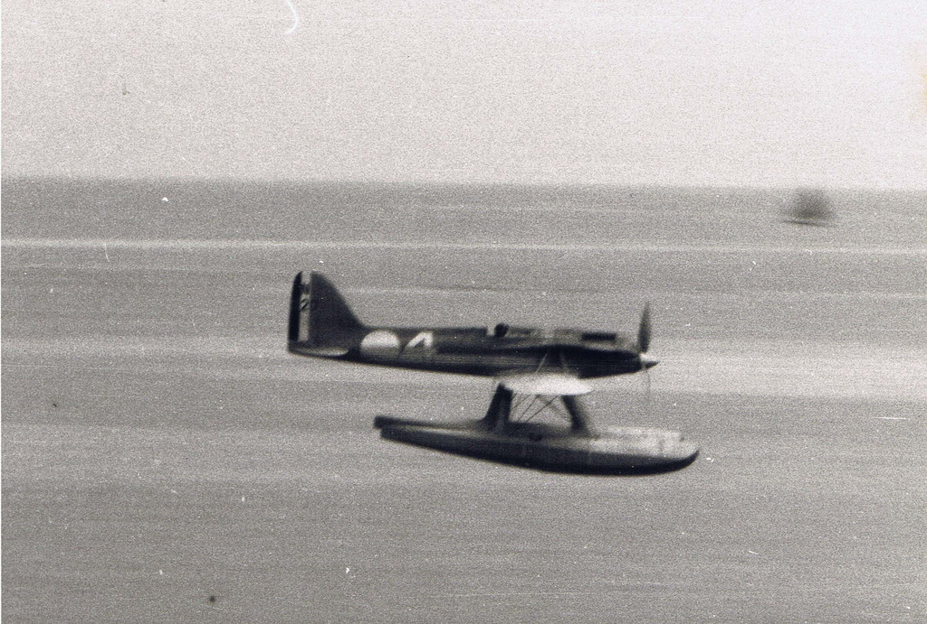

The British pilots used a simple but effective device to track their laps: a small board with holes covered by paper, one of which was punched out after each lap. Flight Lieutenant Webster, uncertain if he had miscounted his laps, completed an additional circuit — but his S.5 still secured victory. His average speed of 281.66 mph set a new world speed record.

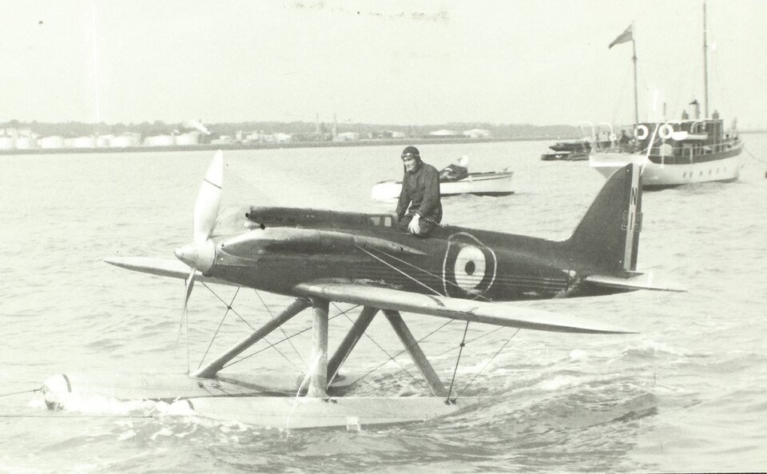

Instalation and usage

You need to have both the plane and scenery from the free add‑on installed. It can be downloaded here: <https://flightsim.to/file/63813/supermarine-s-5>

.NET 8 Runtime is required. Please install it if it is not already present on your Windows system.

After downloading the SchneiderTrophy1927 app, simply unzip the contents anywhere you like. You should see SchneiderTrophy1927.exe inside the SchneiderTrophy1927 folder.

Start MSFS, select the Supermarine S.5 plane, and set the fuel load to 100% (you will need it for the full 7‑lap race). Choose the seaplane base with ICAO code **VN27**. You can start from either dock parking or the water runway. **Do not forget to select a nice weather preset if real‑world weather is not ideal for racing.** Use the parking brake to release the anchor.

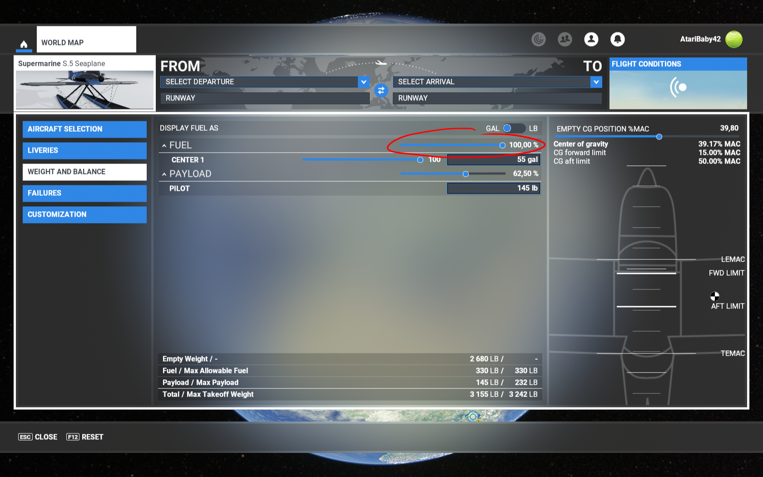

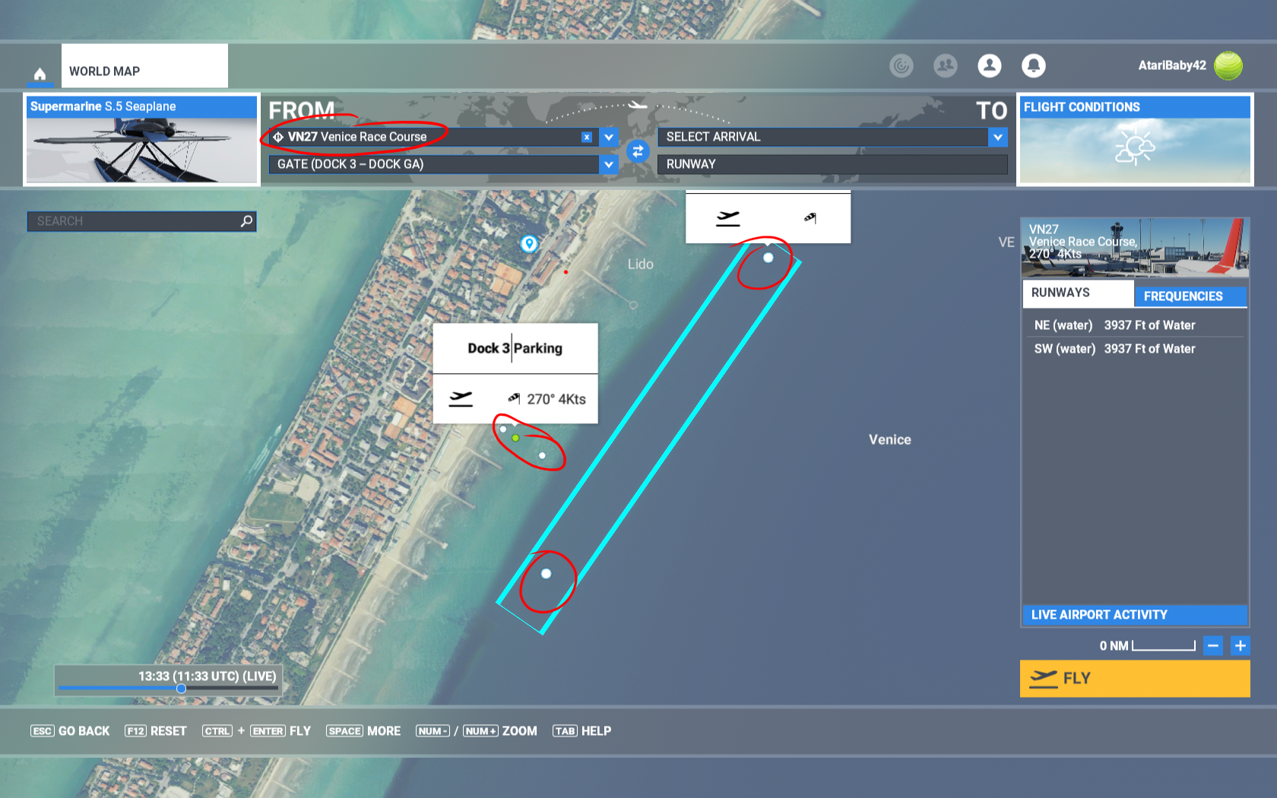

When you are ready to race, run SchneiderTrophy1927.exe. You will see the main menu, where you can select a practice or race session, choose the race track layout, and enable or disable the sound beep lap notifications.

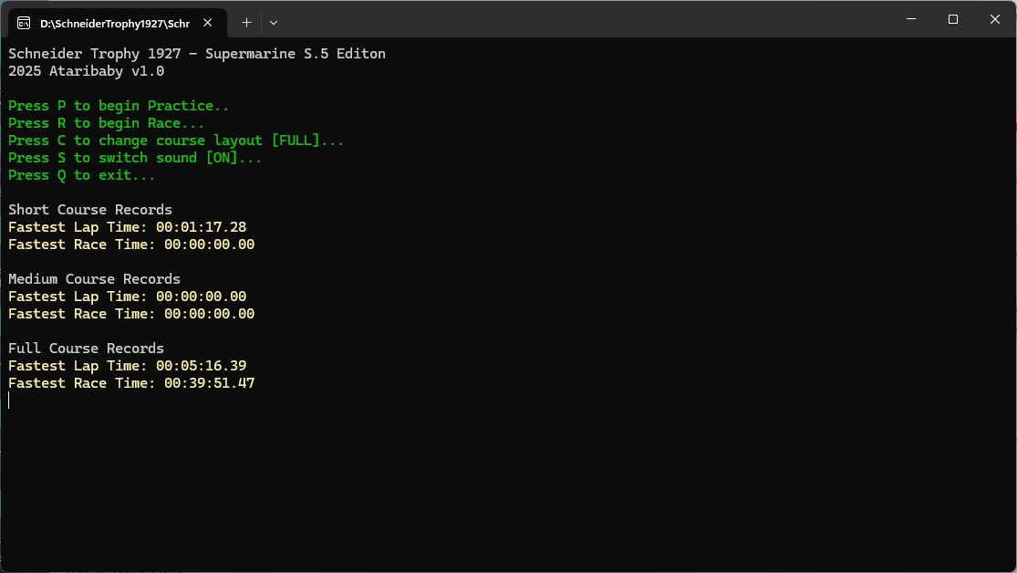

The main menu is straightforward. Below the main options, your best times for each race track layout are displayed. Record times are saved to a times.json file and read back.

**Practice** allows you to fly timed laps. You can complete as many laps as you want, as long as you have enough fuel.

**Race** allows you to fly the full Schneider Trophy 1927 7‑lap race event (or one of two shorter alternate tracks, if selected).

Take‑off is always the same regardless of the chosen track layout. Simply roll from the dock or water runway and take off. It is recommended to take off a little south of the start/finish line to avoid accidentally crossing it and triggering a premature race start.

The start and finish gate crossing is only registered at an altitude higher than 20 ft.

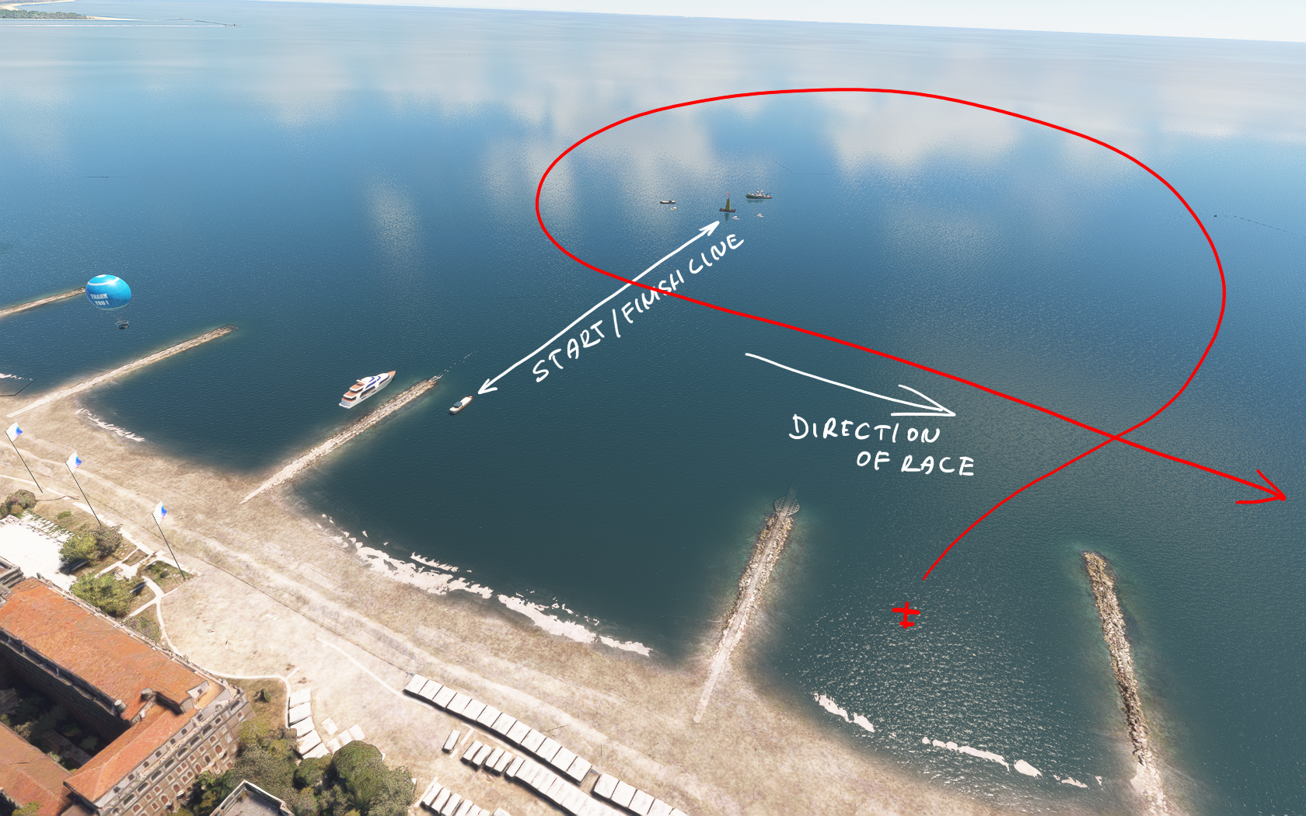

Engine damage is modeled by the app, so keep your engine within limits; otherwise, you risk engine failure.

**Limits:**

* Max Engine RPM: 3300
* Max Water Temperature: 95 °C
* Max Oil Temperature: 145 °C

Monitor your instruments, especially the RPM gauge, during the race.

Race tracks

Descriptions of each race track layout follow. The full layout is a faithful recreation of the 1927 Schneider Trophy course in Venice.

The short and medium layouts are alternative, shorter versions that use one and two turnpoints instead of the original three.

Full

Original 1927 track: uses a triangular layout with three lighthouses as turnpoints.

After the start, head south and pass the Alberoni lighthouse on its right side. Continue south along the coast, then turn at the Chioggia lighthouse and head north toward the San Nicolo lighthouse before returning to pass the start/finish line.

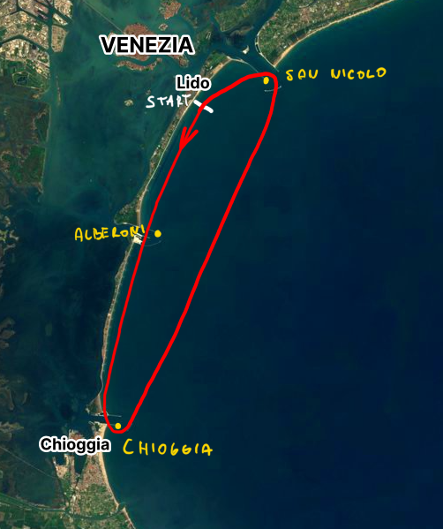

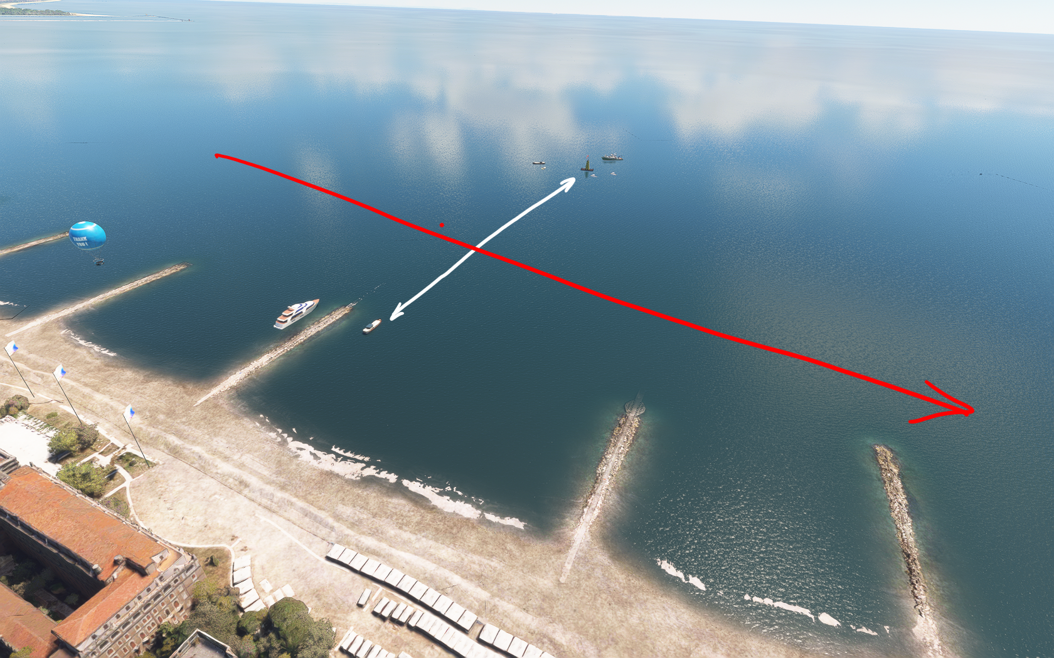

Start/Finish

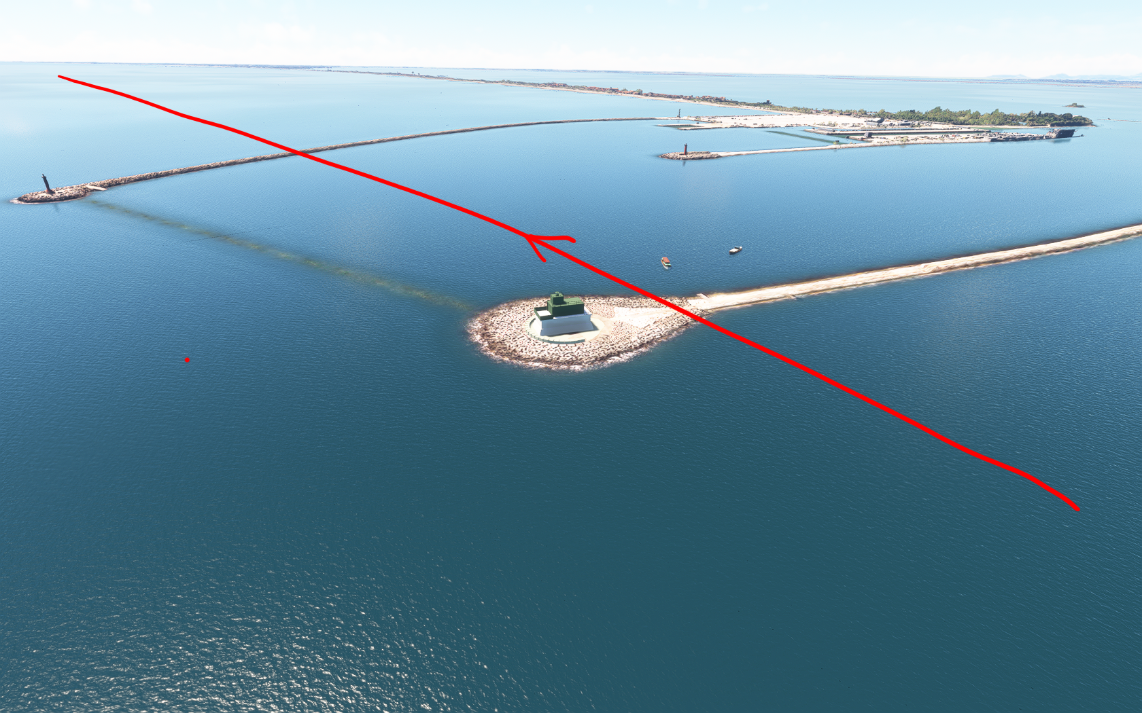

Alberoni

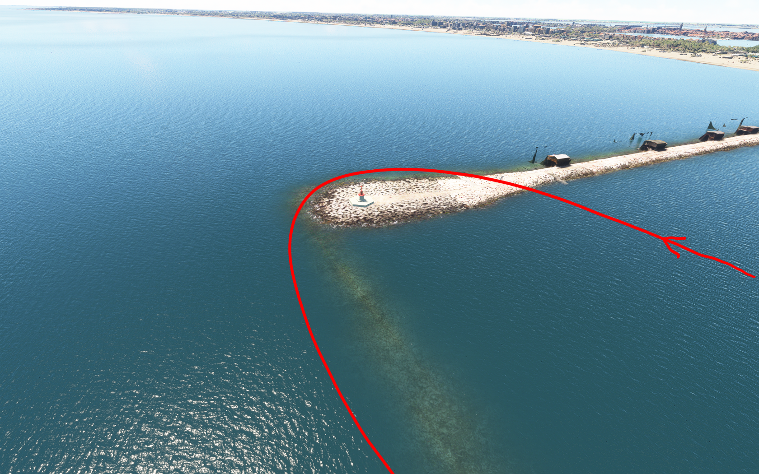

Chioggia

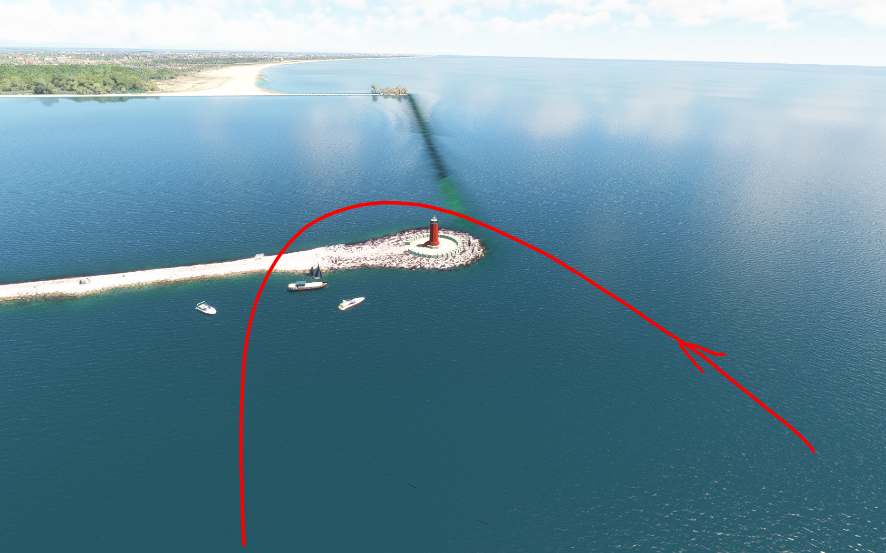

San Nicolo

Medium

Uses a layout with two lighthouses as turnpoints.

After the start, head south and turn at the Alberoni lighthouse. Continue north then turn at the San Nicolo lighthouse before returning to pass the start/finish line.

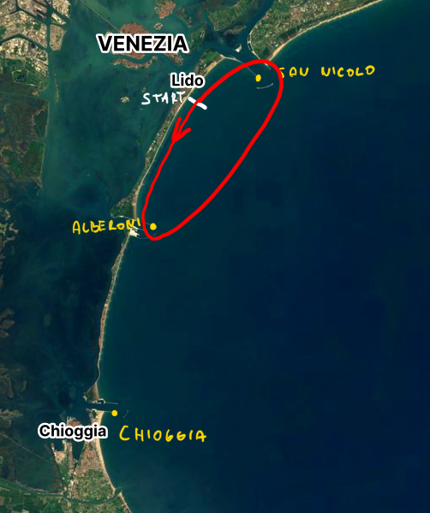



Start/Finish

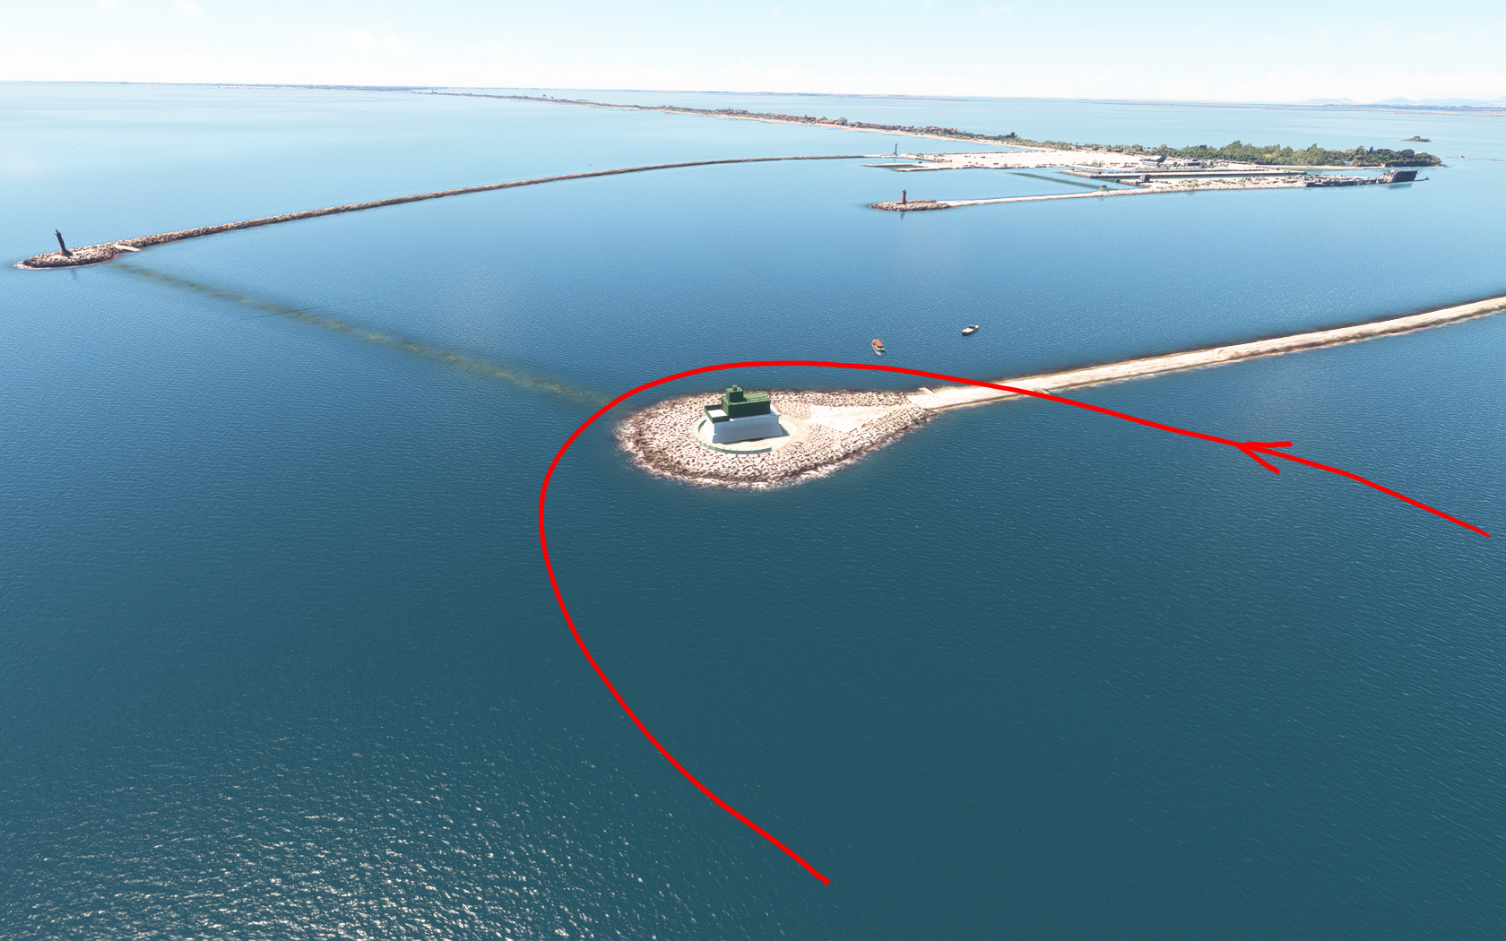

Alberoni



San Nicolo

Short

Uses a layout with one lighthouse as turnpoints.

After the start, head north and turn at the San Nicolo lighthouse. Continue south to pass the start/finish line.

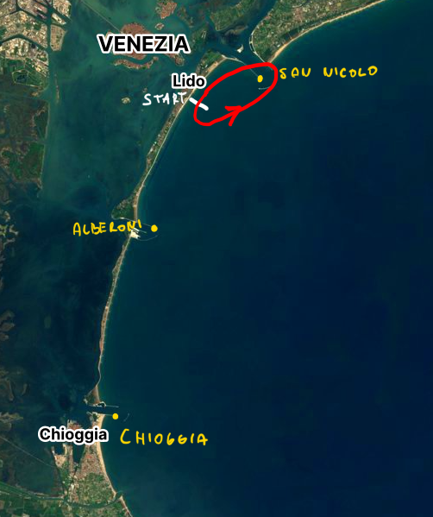

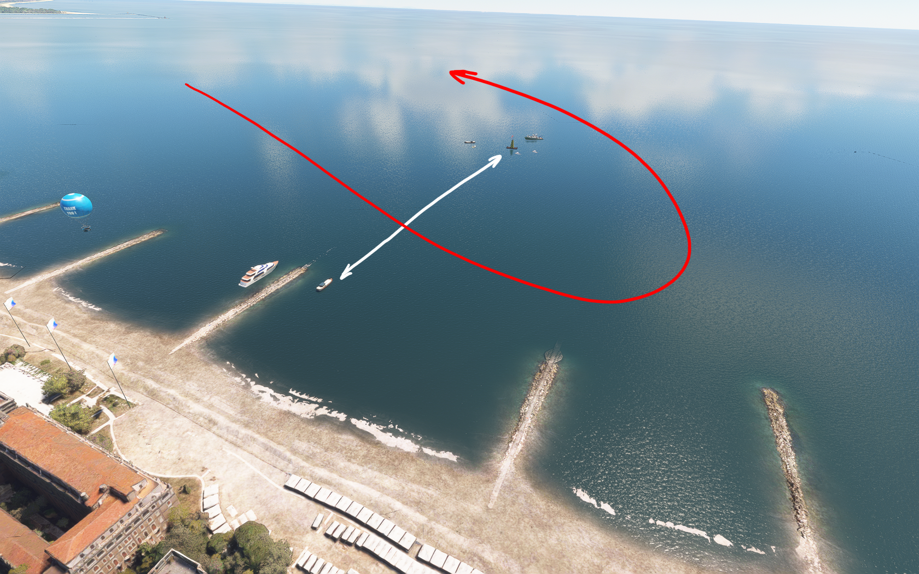

Start/Finish



San Nicolo

La Fine

Good luck with the racing, and have fun!

2025 Ataribaby

Source code availabe <https://github.com/ataribaby42/SchneiderTrophy1927>